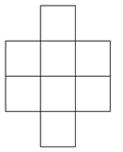
Maths Jam
Place the numbers from 1 to 8 in the grid so that numerically adjacent numbers are not in adjacent cells. In this case, we say two cells are adjacent horizontally, vertically and diagonally.
- If you can't do it, why not?
- If you can do it, in how many ways can it be done?

